**Bilinear transformation**

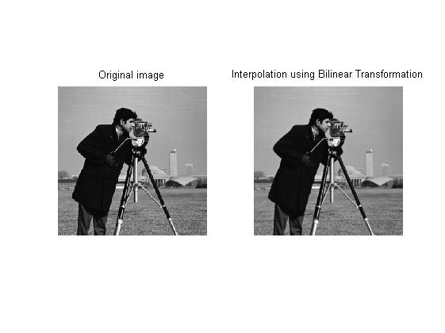

* Implemented by mapping new indexes, (rf,cf) by the formula below:

a(r,c).*(1 - deltar).*(1 - deltac) + a(r,c+1).*(1-deltar).*(deltac) + a(r+1,c).*(deltar).*(1 - deltac) + a(r+1,c+1).*(deltar).*(deltac);

where,

deltar=change in row from a particular pixel

deltac=change in column from particular pixel

* Root Mean Square Error using this implementation=13.859.